Cable Section to Zone Brief

This document will attempt to step through the setup and theory behind Cable Channels, Sections and Zones for the PALCOM server

Definitions

* **Cable Channel:** (Referred to as simply **cable** below) Physical connection on PAL-AT device that a sensor cable and probe network connects to. The PAL-AT 30C has a single cable channel and the 30k has 4 cable channels
* **Section:** Identifiable length of sensor cable, jumper cable, or probe connected to a channel. May be grouped with other sections irrespective of Cable or Panel through the use of Zones.
* **Zone:** Logical grouping of Sections for reporting, identification and locational representation. Each zone can have multiple sections from across multiple Cables and Panels.

# Step 1 – Setting up Panel

Upon initial setup and connecting to a panel, the Server will upload the cable setup data for each cable connected to the PAL-AT.

## Physical System Example

Below is a linear spatial representation of the system we are going to be looking at. Initially, the PAL-AT is setup with the PHYSICAL connections as shown below on CABLE 1. The distance of each individual piece of cable/probe is labeled. *We assume that the installer setup the panel with each piece of cable or probe as a section.*

|  |  |
| --- | --- |
| Graphic | Device Type |
|  | JMP Cable |
|  | AGW Gold Cable |
|  | Probe |

20m

20m

20m

Device 1

Cable 1

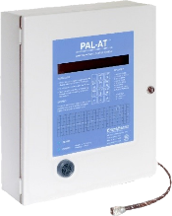

200m

300m

20m

## Initially uploaded Cable Section information

Upon connecting to this new panel and uploading the cable data, the system will have the below information describing the connected cables and sections. For simplicity, we are only using a sing cable connected to our panel. However additional sections tied to the same panel would have their own cable ID (eg Cable 2) and section data depending on types and lengths connected inline to the cable.

|  |  |  |  |  |  |  |
| --- | --- | --- | --- | --- | --- | --- |
| Device | Cable | Section Numbers | Section Cable Type | Section Length (m) | Counts (estimated) | Total Counts |
| Device 1 | Cable 1 | 1 | 3 (JMP) | 20 | 14 | 14 |
| 2 | 13 (AGW Gold) | 300 | 166 | 180 |
| 3 | 10 (Probe) | 20 | 14 | 194 |
| 4 | 13 (AGW Gold) | 200 | 110 | 304 |
| 5 | 10 (Probe) | 20 | 14 | 318 |
| 6 | 3 (JMP) | 20 | 14 | 332 |

Once the system is setup as with the above, it will generate leaks as being generated a linear cable distance away from the panel. The panel keeps a record of sections to identify different types of cable, or locations of connectors as identified by the installer, but it does not refer back to the section information for determining and identifying the locations of leaks. It is the PALCOMs responsibility to take and tie distances back to sections and zones. Below are some examples of leaks that the system might generate. NOTE: Probes are numbered 1 to N starting with the closest to the panel.

* Leak at 30m into section 2 – PAL-AT will alert of leak on Cable 1 at 50m
* Leak at 100m into section 4 – PAL-AT will alert of a leak on Cable 1 at 440m
* Leak at Section 5 Probe – PAL-AT will alert Probe 2 activated (2nd probe in cable)
* Break at 123m into section 2 – PAL-AT will alert of break detected on Cable 1 at 143m

# Step 2 – Editing for more logical sections / Preparing for zones

Ideally, the cable sections for the device should be installed and defined in a manner that makes logical sense. However, the installed sections and the physical locations being monitored don’t always align in an easily identifiable way. With the added ability to tie multiple SECTIONS to a ZONE, it might become necessary for the user to adjust how the sections are represented on the panel.

Below is the same cable uploaded from the panel earlier. The cable sections are labeled accordingly, but now boxes have been placed to show that sections are actually monitoring zones.

ZONE 4

ZONE 3

ZONE 2

ZONE 1

3

6

5

4

2

1

Ultimately, related sections of cable will be grouped into these logical Zones. However, remembering that each cable section can only have a single zone, we need to make some logical changes to the way the sections are setup to allow the above grouping. Specifically, **Section 2** in the above cable needs to be separated into 2 sections. Using the cable page of the PALCOM server, we will need to insert a section between Section 1 and Section 2 or Section 2 and Section 3.

Assuming Zone 1 ends at 100m into Section 2, we add a section to the cable as shown highlighted in the below table. All sections IDs beyond the new section are incremented accordingly, and values are recalculated where necessary. This updated table of cable information would be updated to the PAL-AT so the server and PAL-AT remain in sync.

|  |  |  |  |  |  |  |
| --- | --- | --- | --- | --- | --- | --- |
| Device | Cable | Section Numbers | Section Cable Type | Section Length (m) | Counts (estimated) | Total Counts |
| Device 1 | Cable 1 | 1 | 3 (JMP) | 20 | 14 | 14 |
| 2 | 13 (AGW Gold) | 100 | 56 | 70 |
| 3 | 13 (AGW Gold) | 200 | 110 | 180 |
| 4 | 10 (Probe) | 20 | 14 | 194 |
| 5 | 13 (AGW Gold) | 200 | 110 | 304 |
| 6 | 10 (Probe) | 20 | 14 | 318 |
| 7 | 3 (JMP) | 20 | 14 | 332 |

Below is the spatial representation of the cable with sections updated and zones labeled.

ZONE 4

ZONE 3

ZONE 2

ZONE 1

7

6

5

1

2

3

4

Once completed, the

*Application Note: Having ZONE 1 and ZONE 2 connect via sensor cable running into each other without a piece of jumper between is not ideal. The system may falsely identify the zone being activated when a leak is registered close to the edge of the two zones. In this scenario, PermAlert would likely recommend adding another 20m section of jumper between Cable Section 2 and Cable Section 3 (cutting and splicing in a physical piece of jumper), and adding the jumper to the table accordingly before updating the PAL-AT with the new cable information. For simplicity, this is ignored in this scenario.*

# Step 3 – Creating Zones

Zones are intended to logically group section together spatially. Zones have a hierarchal relationship that makes sense to the area being monitored by a PermAlert system. Any level of a zone hierarchy can be assigned sections, or be left purely hierarchal. Assume we create a hierarchy setup for Building 1 as detailed below in the ZONES settings of the PALCOM web page.

Setup similar to the below on the web page

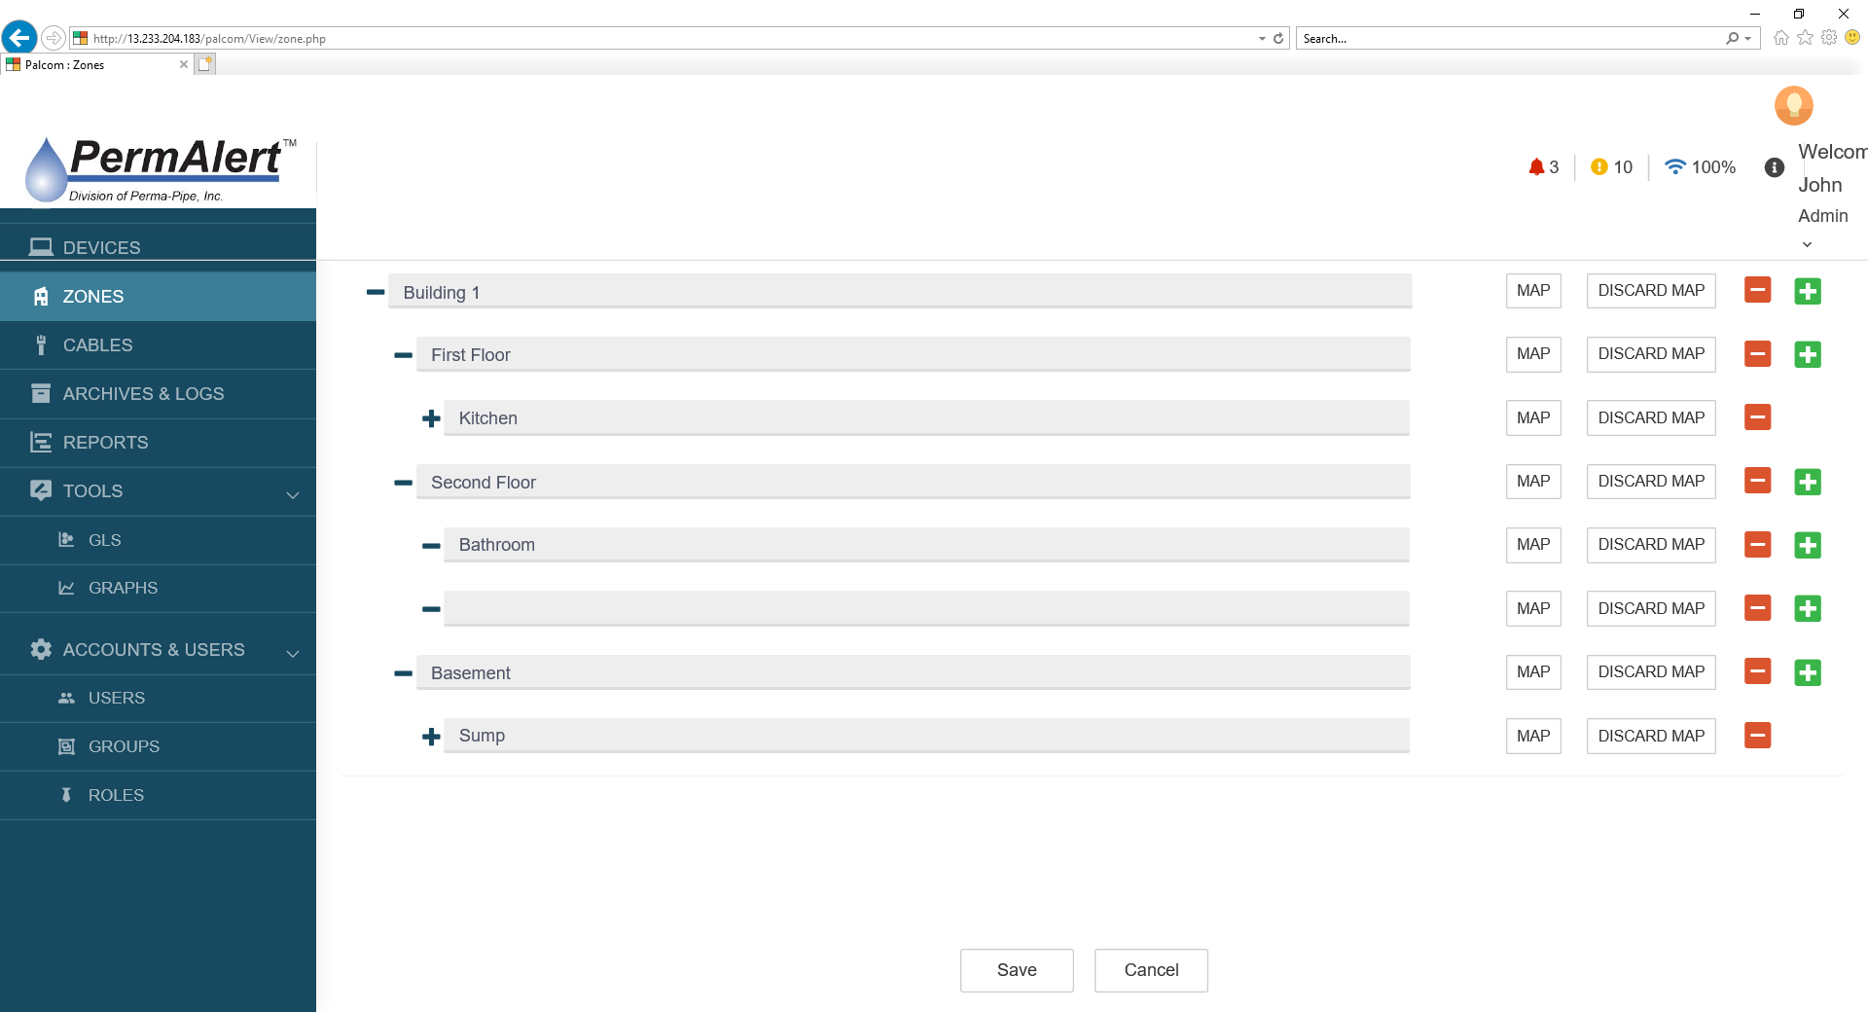

# Step 4 – Assigning Cable Sections to Zones

Once a zone is setup, Cable Sections can be added to if from a list of available sections using the following rules:

* A section can only be assigned to 1 zone
* Once a section is assigned, it no longer shows up on the list of available sections

This should be done on the ZONES page, which should provide an “at a glance” view of the zone hierarchy and a list of cable sections assigned under each level. Theas can be added to the same hierarchy with a different color to indicate it’s a physical cable section instead of just a part of the zone

Assume we assign the sections as detailed in the new column in the below table

|  |  |  |  |  |  |  |  |
| --- | --- | --- | --- | --- | --- | --- | --- |
| Device | Cable | Section Numbers | Section Cable Type | Section Length (m) | Counts (estimated) | Total Counts | Zone |
| Device 1 | Cable 1 | 1 | 3 (JMP) | 20 | 14 | 14 | Building 1:  First Floor:  Kitchen |
| 2 | 13 (AGW Gold) | 100 | 56 | 70 |
| 3 | 13 (AGW Gold) | 200 | 110 | 180 | Building 1:  Second Floor:  Bathroom |
| 4 | 10 (Probe) | 20 | 14 | 194 | Building 1:  Basement:  Sump |
| 5 | 13 (AGW Gold) | 200 | 110 | 304 | Building 1:  Basement |
| 6 | 10 (Probe) | 20 | 14 | 318 |
| 7 | 3 (JMP) | 20 | 14 | 332 |

The zone hierarchy becomes the below with sections assigned in green. This should be represented in the “ZONES” screen.

# Step 5 – Assigning Cables / Zones to GLS

### Cables can be added to GLS by section.

* Load an image file to overlay cables
* Select section to draw from dropdown list of available sections
* Once a section is used, it comes off the list
  + Special case for editing existing cable to change geometry.
* Simple drawing of lines and arcs on wireframe layout of building
  + Multiple button clicks allowed per line to move end point, adjust length, stretch arcs, etc.
  + Once line is drawn to user’s liking, save it to set the beginning and end distances (known by system already as part of section information)
  + Add calibration points to section as needed
  + Floating over cable shows Device : Cable : Section : Assigned-Zone information
    - Amount of information on float over should be selectable in the GLS viewer
  + Floating over calibration point additionally shows distance
* In a leak event, the system calculates where on the line to illustrate a leak by calculating between two closest calibration points.

Mock up of First Floor Kitchen. Section 2 placed with 3 calibraion points (2 end pionts at 20m and 120m, plus additional calibration piont around middle). Shwoing highlighted calibration piont information (Left). Leak detected between calibration points (right).

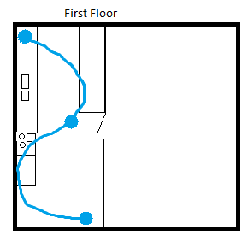

* Device 1
* Cable 1
* Section 2

Building 1 >> First Floor >> Kitchen

70m:42counts

### Zones can be added to GLS by polygon.

* Load an image file to overlay zone
* Select zone from dropdown
* Once a zone is used, it comes off the list
  + Special case to EDIT a zone as opposed to add for changing size/shape
* Draw squares, circles and polygons to include areas of zone.
  + Multiple button clicks allowed per line to move end point, adjust length, stretch arcs, etc.
  + Once zone is drawn to user’s liking, save it as an overlay
  + Zone color indicates status
  + Zone information can show entire logic tree *Building 1:First Floor:Kitchen* or just the single level (selectable)
* In a leak event, the system highlights the zone.
  + Only active zone level highlights for nested zones
    - Example from above: If “Building 1: Basement: Sump” is active, only the lowest level “Building 1: Basement: Sump” is active. “Building 1: Basement” remains inactive even though “Sump” is a subset

Mockup of zone inactive (left) and active (right)

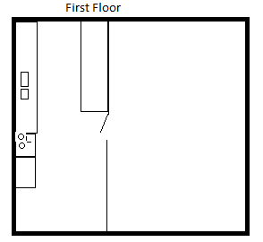

Kitchen

Kitchen

### Zones and cables in conjunction

* Zones can be overlaid with other zones and cable sections.
  + It is the User’s responsibility to ensure that the Zone overlaid with a cable section makes sense (i.e. the section is overlaid with the zone it’s assigned to).
  + There might be reasons for a cable/zone mismatch.
    - Can we give warning, list or highlight sections that are assigned to different zones than have been overlaid?



Kitchen

Kitchen